**R Code for Examples in the book**

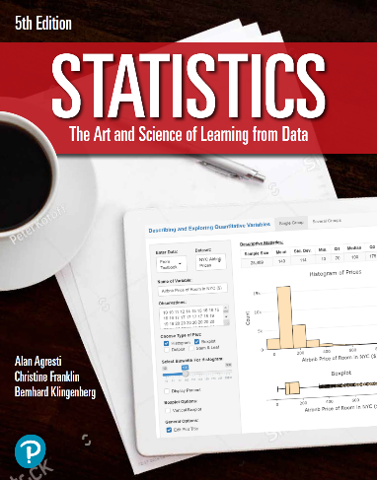

***“Statistics: The Art and Science of Learning from Data”***

**by Agresti, Franklin and Klingenberg, 5th edition**

**Chapter 3**

**Example 10: Baseball Scoring – Regression Equation**

## Reading in the data

baseball <- read.csv(file='https://raw.githubusercontent.com/artofstat/data/master/Chapter3/AL_team_statistics.csv')  
attach(baseball) # so we can refer to variable names

## Fitting in regression model

linReg <- lm(scoring ~ batting)

## Viewing model

linReg

##   
## Call:  
## lm(formula = scoring ~ batting)  
##   
## Coefficients:  
## (Intercept) batting   
## -2.32 26.07

## From this model, you can obtain the regression equation: Team Scoring = -2.32 + 26.07 * Batting Average.

## To use this model to predict a given team’s score given its batting average, you can substitute their batting average in the equation.

-2.32 + 26.07 * 0.27

## [1] 4.7189

## or you can use the predict() function

new <- data.frame(batting = c(0.27))  
predict(linReg, newdata = new)

## 1   
## 4.719605